# **PHP Project Documentation**

## Problem Statement

To address the inconvenience of visiting doctors and waiting in long queues, the CARE Group seeks to develop a website where users can search for doctors and book appointments online. The site will manage detailed information about doctors and patients and offer relevant medical information.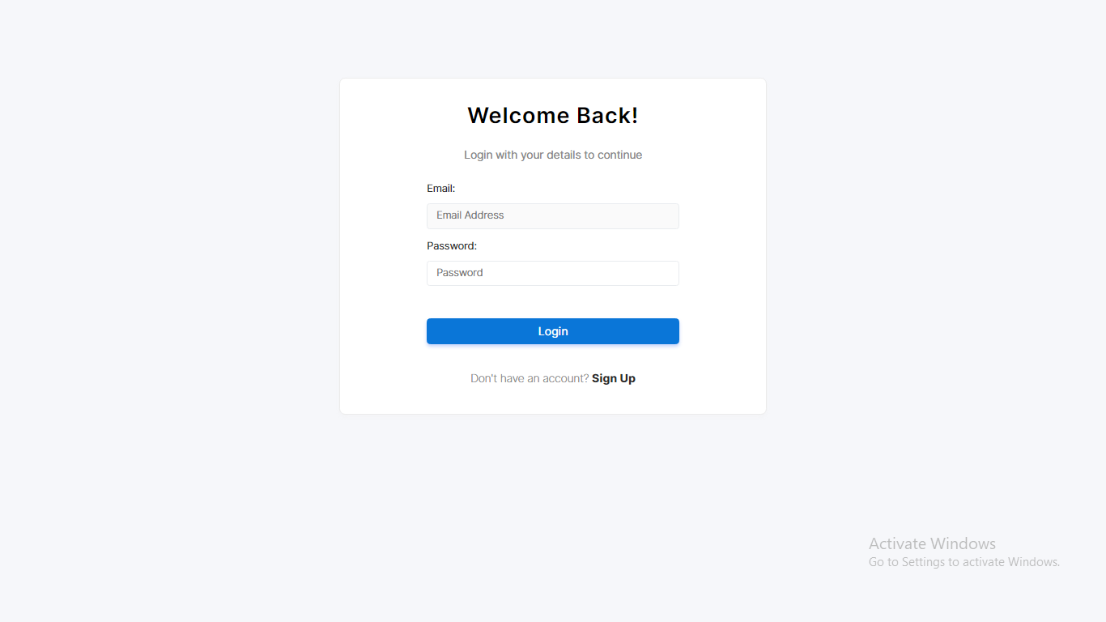

## Project Functionality

### **Admin:**

* **Manage Cities/Doctors/Patients:** Add, modify, and delete records.
* **User Management:** Create and manage user accounts and access.
* **Content Management:** Update website content, including medical news and information.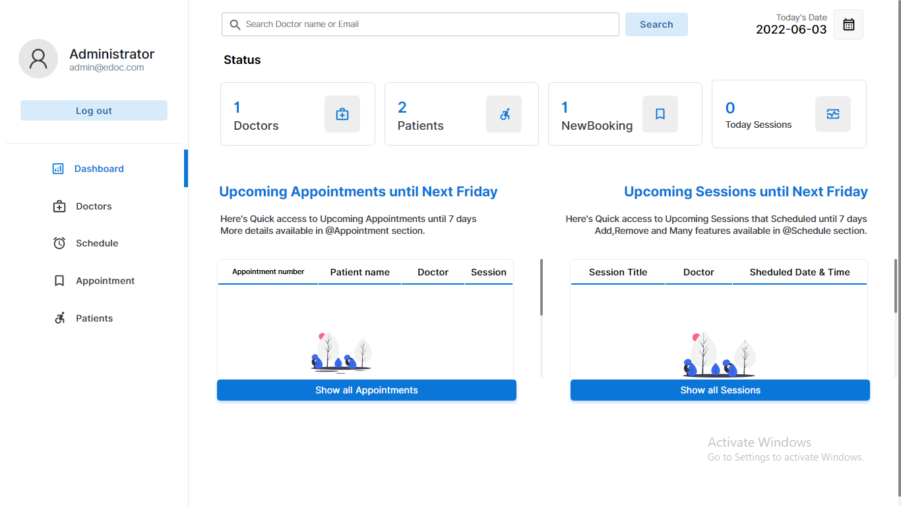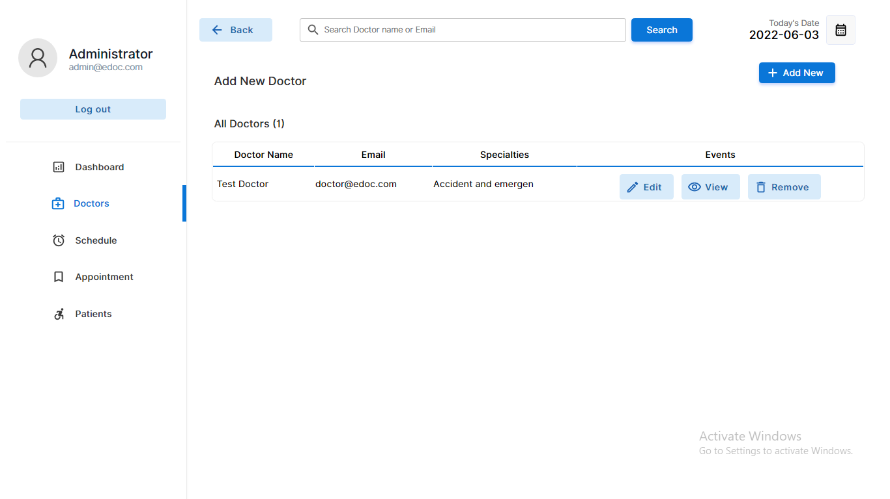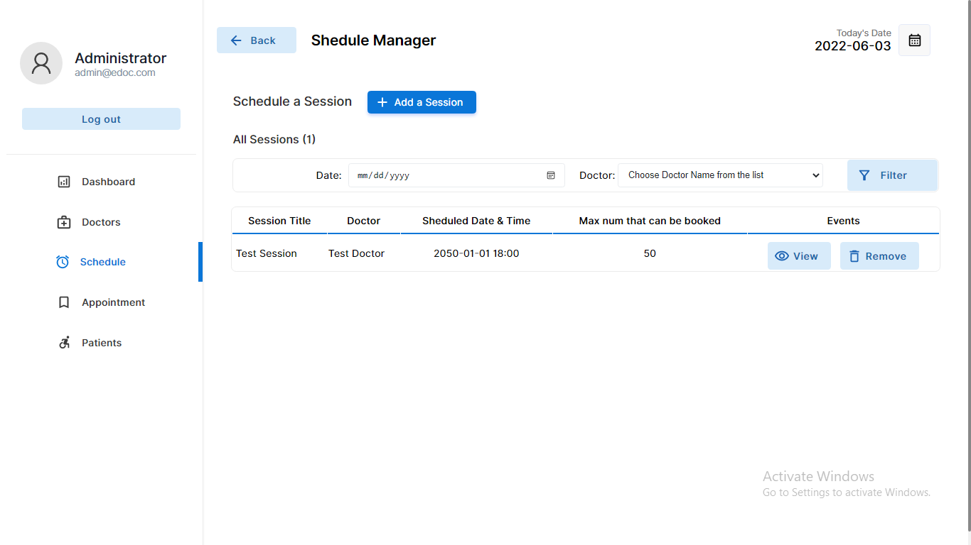

### **Doctor:**

* **Profile Management:** View and update personal details.
* **Appointment Management:** View and manage appointments and availability.
* **Dashboard Access:** Overview of profile and appointments.

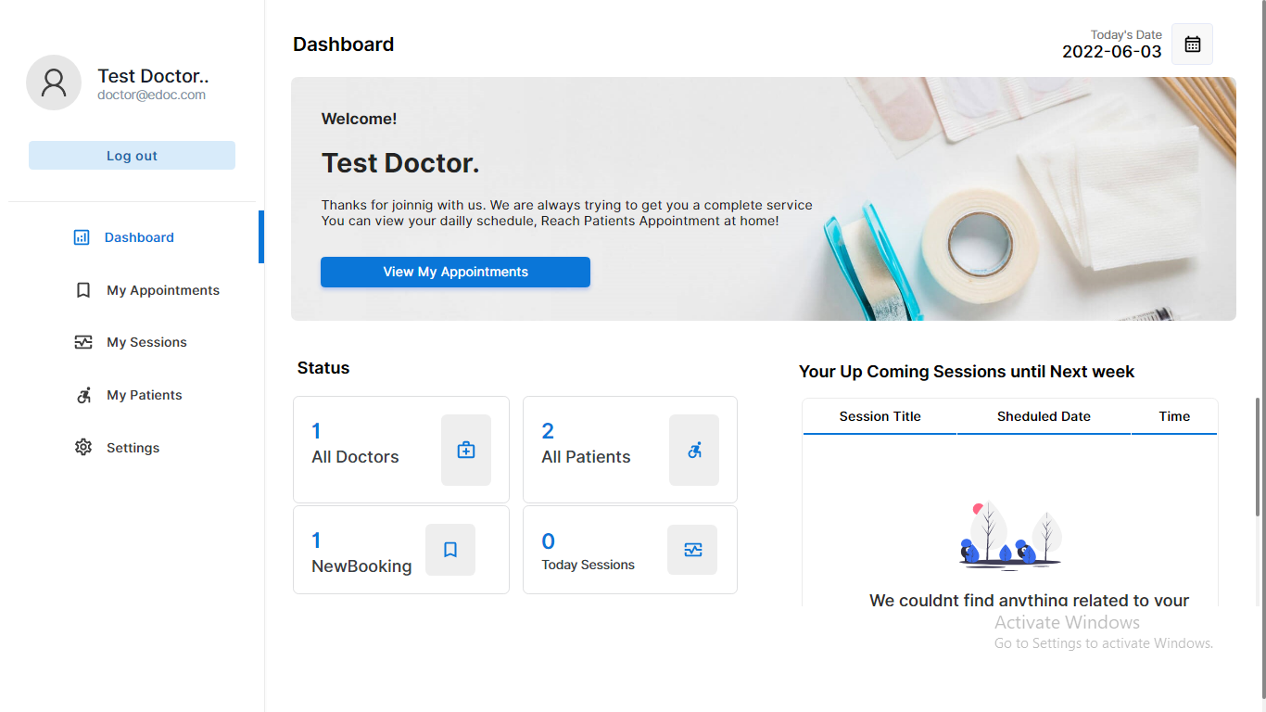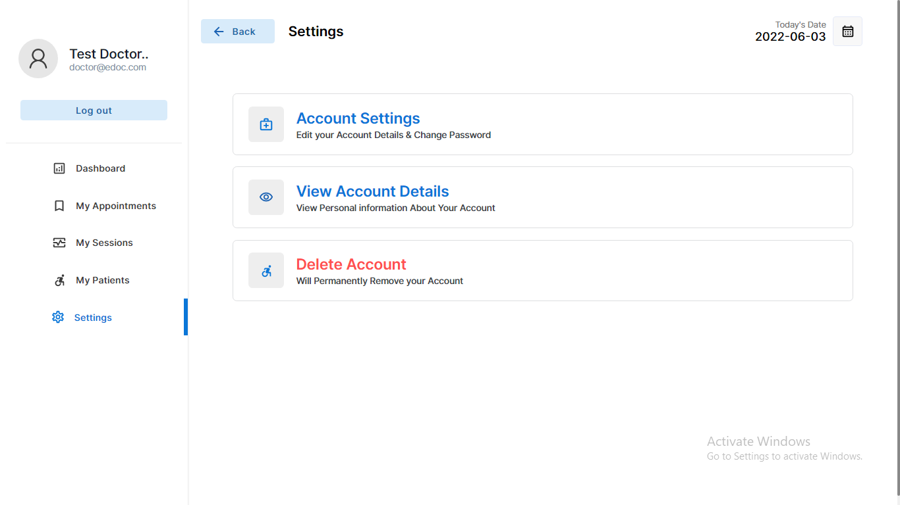

### **Patient:**

* **Account Registration:** Create and manage user accounts.
* **Doctor Search:** Search for doctors by location and specialty.
* **Appointment Booking:** Check availability and book appointments.
* **Profile Management:** View and update personal details.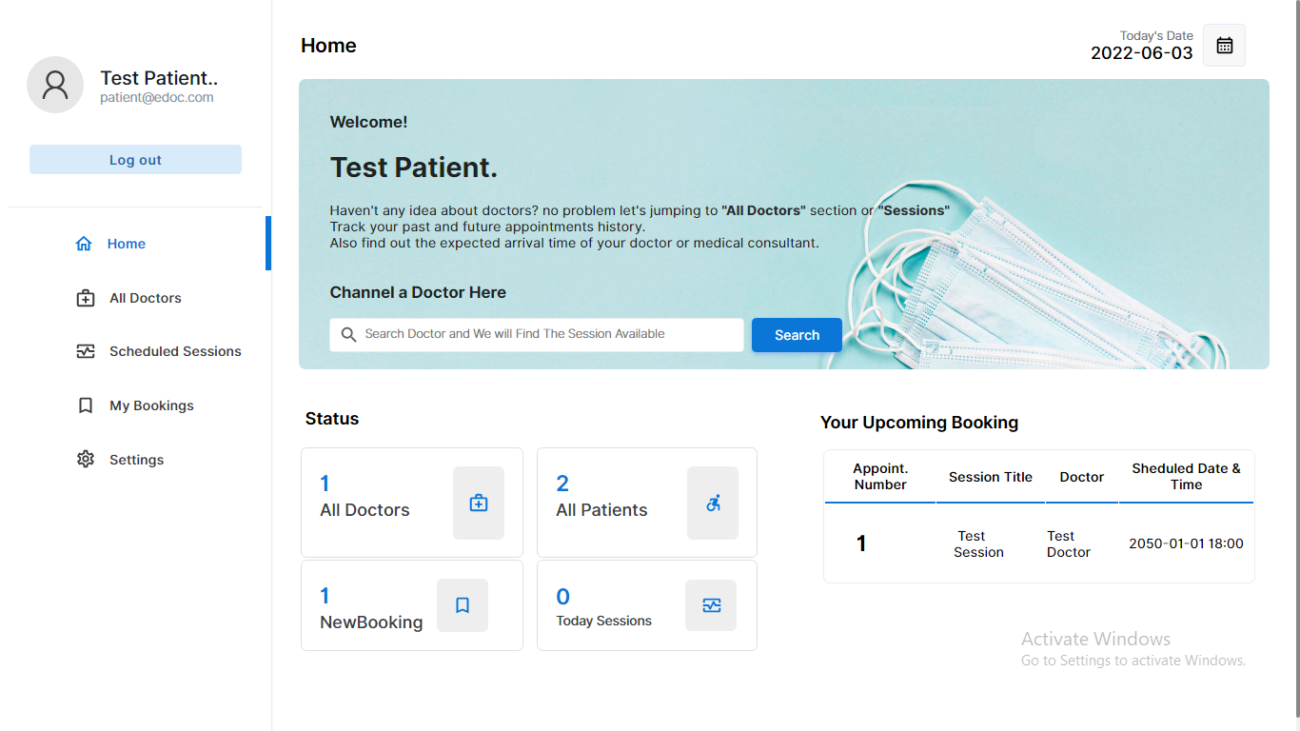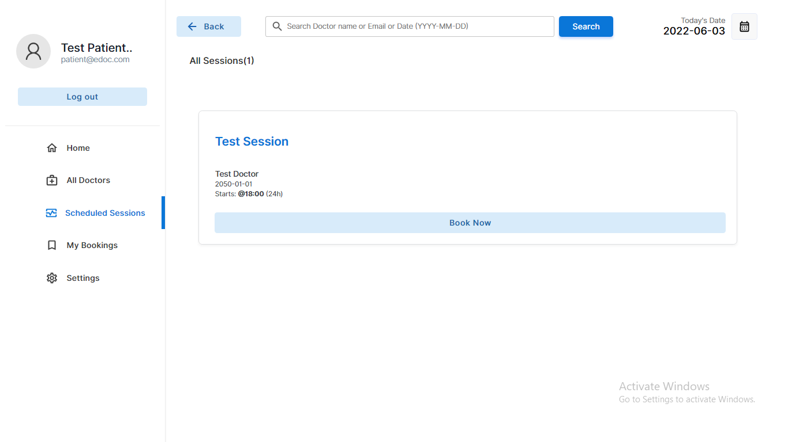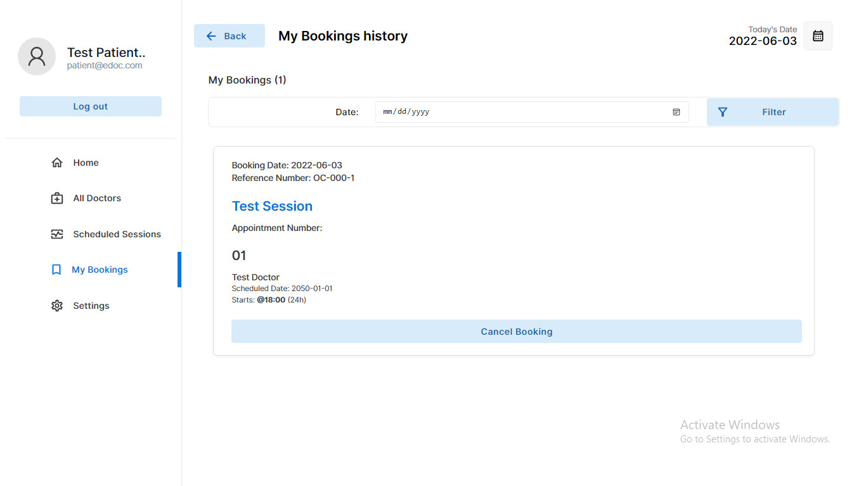

## Implementation Overview

* **Admin Section:** Manage doctors, patients, cities, and appointments.
* **Doctor Section:** Manage profile, view appointments, and update availability.
* **Patient Section:** Register, search doctors, book appointments, and manage profile.

## Database Connection

The connection.php file establishes a connection to the MySQL database, which stores information about users, doctors, patients, and appointments.

## Team:

This PHP Project is completed by Burhan and Raqeeb Uddin.